# Distribution of Amir's Sales - Probability Distribution

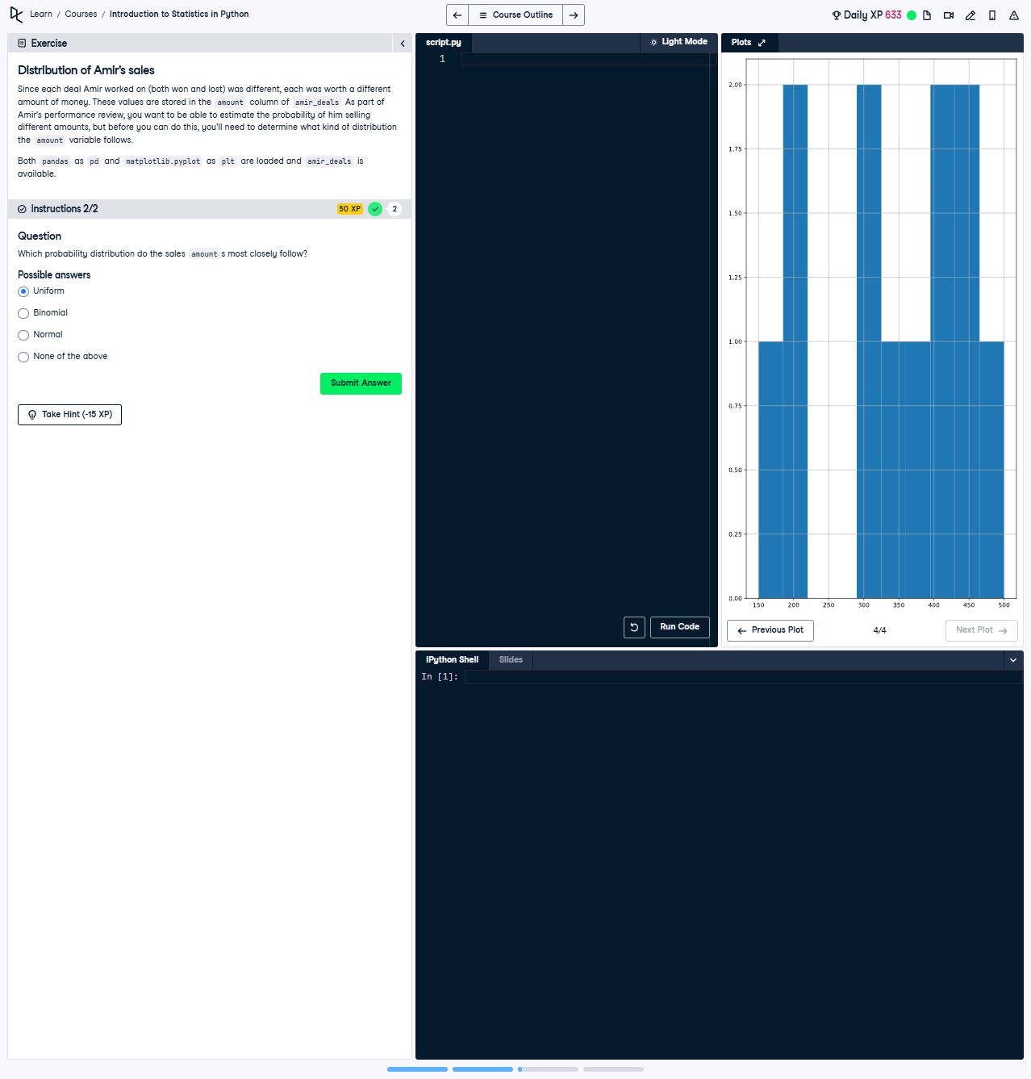

## Question:

Which probability distribution do the sales 'amount' most closely follow?  
Possible answers:  
- Uniform  
- Binomial  
- Normal  
- None of the above

## Explanation of the Question:

This question involves analyzing the distribution of Amir's sales amounts based on the histogram. The objective is to match the pattern in the histogram with one of the provided probability distributions.

## Answer:

The distribution most closely resembles a **Normal** distribution.  
  
Explanation: A normal distribution has a bell-shaped curve where most data points cluster around the mean. The histogram provided shows a concentration of sales amounts in the middle ranges, tapering off at the extremes, indicating a normal distribution.

## Explanation of the Answer:

The histogram indicates that the sales amounts are not evenly distributed but rather cluster around a central value, with fewer amounts at the lower and higher extremes. This is characteristic of a normal distribution, where data is symmetrically distributed around the mean.